**POC of External Table**

**Step 1:** Set Up Directory in Oracle

CREATE OR REPLACE DIRECTORY ext_data_dir AS ‘/develop/in’;GRANT READ, WRITE ON DIRECTORY ext_data_dir TO your_user;

**Step 2:** Prepare the External Data File

Prepare a data file (e.g., sample_data.txt) with a format that matches the structure of the external table you’ll create. For example:

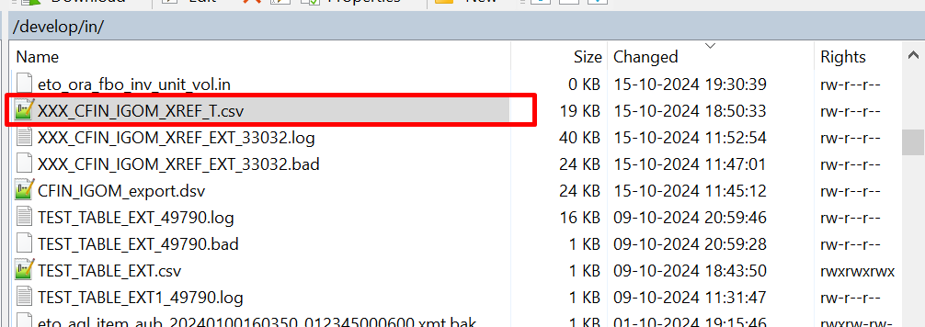

**Step 3:** Create the External TableNow, create an external table that matches the structure of the data in the file.

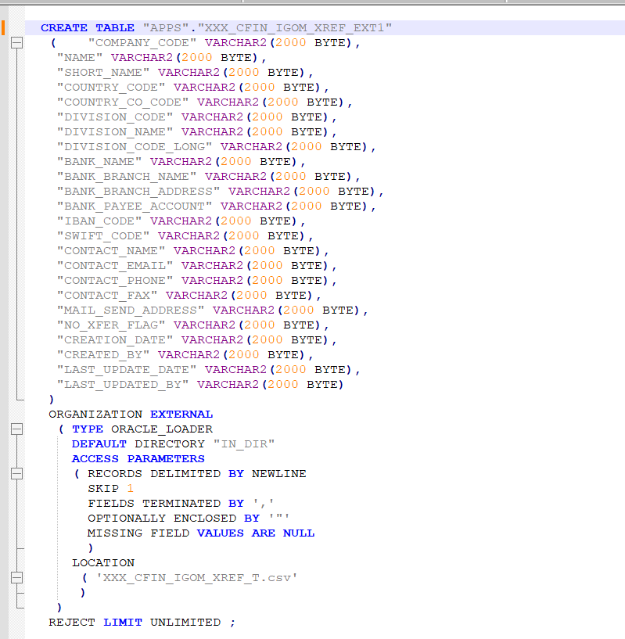

**ORGANIZATION EXTERNAL:** Specifies that this table is external.

**TYPE ORACLE_LOADER:** Uses Oracle’s loader mechanism to read data.

**ACCESS PARAMETERS:** Defines how to read and parse the data file.

**SKIP 1:** To skip the first line in the file.

**FIELDS TERMINATED BY ',':** Specifies the delimiter.

**OPTIONALLY ENCLOSED BY '"':** Handles data enclosed in quotes.

**MISSING FIELD VALUES ARE NULL:** Allows NULLs for missing fields.

**LOCATION:** Specifies the filename (in the directory specified earlier).

**Step 4:** Query the External TableOnce the external table is created, you can query it just like a regular table.

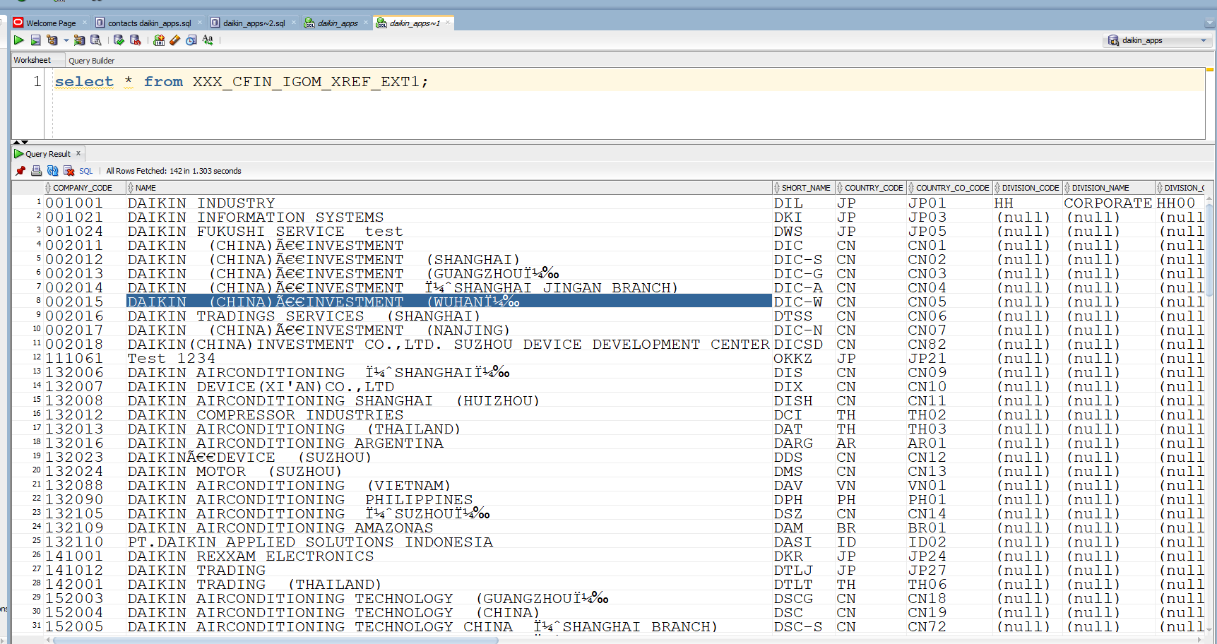

**Step 5:** Handle Errors and Bad Data

Oracle creates two optional files in the directory to handle errors:

**Log File:** Logs query and data errors.

**Bad File:** Records rows that could not be read.

